A gathering for river and land managers…

2016
River Ranger Rendezvous
August 16-18

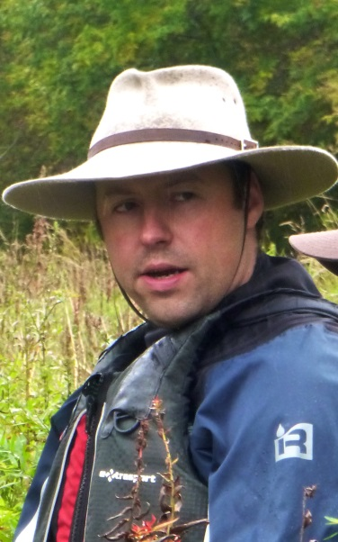
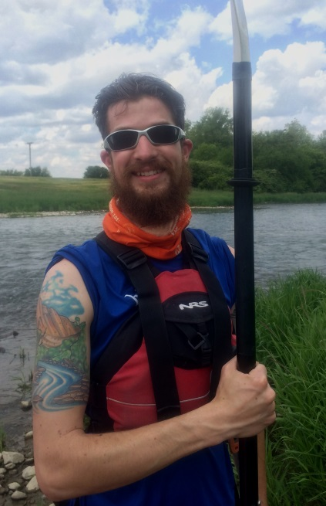
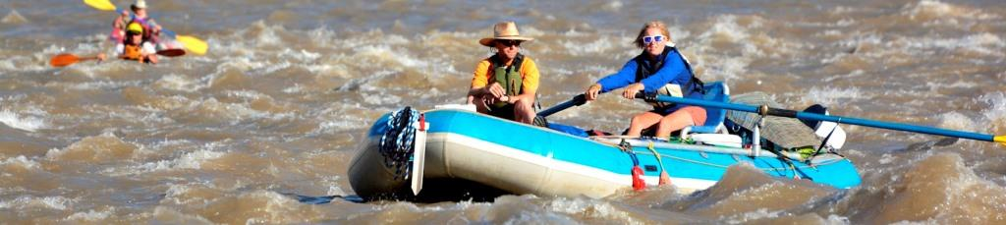

Sponsored by:
River Management Society
SW Chapter &
Dinosaur National Monument
Green River
Lodore Canyon
Dinosaur National Monument

3 days, 2 nights - shuttle provided
meals provided by O.A.R.S.

Registration covers campground fees, meals, and permits:
by July 15 $200 RMS members, $235 non-members
after July 15 $210 members, $245 non-members
For more information:
visit http://www.river-management.org/southwest
or contact Greg Trainor ptrainor7@msn.com

